Collins – Receiver Control – HF 8094 and the HF-8054A (21 February 2014)
Receiver used:
HF-8054A (100 Hz step; External Standard; Remote Kit; 6 KHz filter; 4 Ch. ISB)
Cable information (assuming both are within 50 feet of each other)
HF-8094 | HF-8054 | Function | Wire Color
2 | 2 | Control | Black
14 | 14 | Control Return | Red
15 | 15 | Control Shield | Braid
3 | 3 | Monitor | Black
16 | 16 | Monitor Return | Red
17 | 17 | Monitor Shield | Braid
N/C | 8 | Receiver Address Bit 1 | Pin 8-22 on Receiver
N/C | 9 | Receiver Address Bit 2
N/C | 10 | Receiver Address Bit 3
N/C | 11 | Receiver Address Bit 4
N/C | 12 | Receiver Address Bit 5
N/C | 22 | Address Ground | Pin 8-22 on Receiver
N/C | 24 | Address Ground

Receiver Addressing (Uses classical BCD) – Only works with the RS-232/RS-485 signaling
Address | Bit 1 | Bit 2 | Bit 3 | Bit 4 | Bit 5
0 | Open | Open | Open | Open | Open
1 | Ground | Open | Open | Open | Open
2 | Open | Ground | Open | Open | Open
3 | Ground | Ground | Open | Open | Open
4 | Open | Open | Ground | Open | Open
5 | Ground | Open | Ground | Open | Open
6 | Open | Ground | Ground | Open | Open
7 | Ground | Ground | Ground | Open | Open
8 | Open | Open | Open | Ground | Open
15 | Ground | Ground | Ground | Ground | Open

Check all your system board options. Using 9600 or 19.200 is recommended for ALE use.
It will work with receiver address “0” but it is recommended to use Address 1 as the default.
The Audio lines connect straight across between Control unit and the Receiver. On the HF-8094, use the audio input connections (not the “out” connections). Ensure you are connecting the right audio lines to the right locations. It is easy to make a mistake.

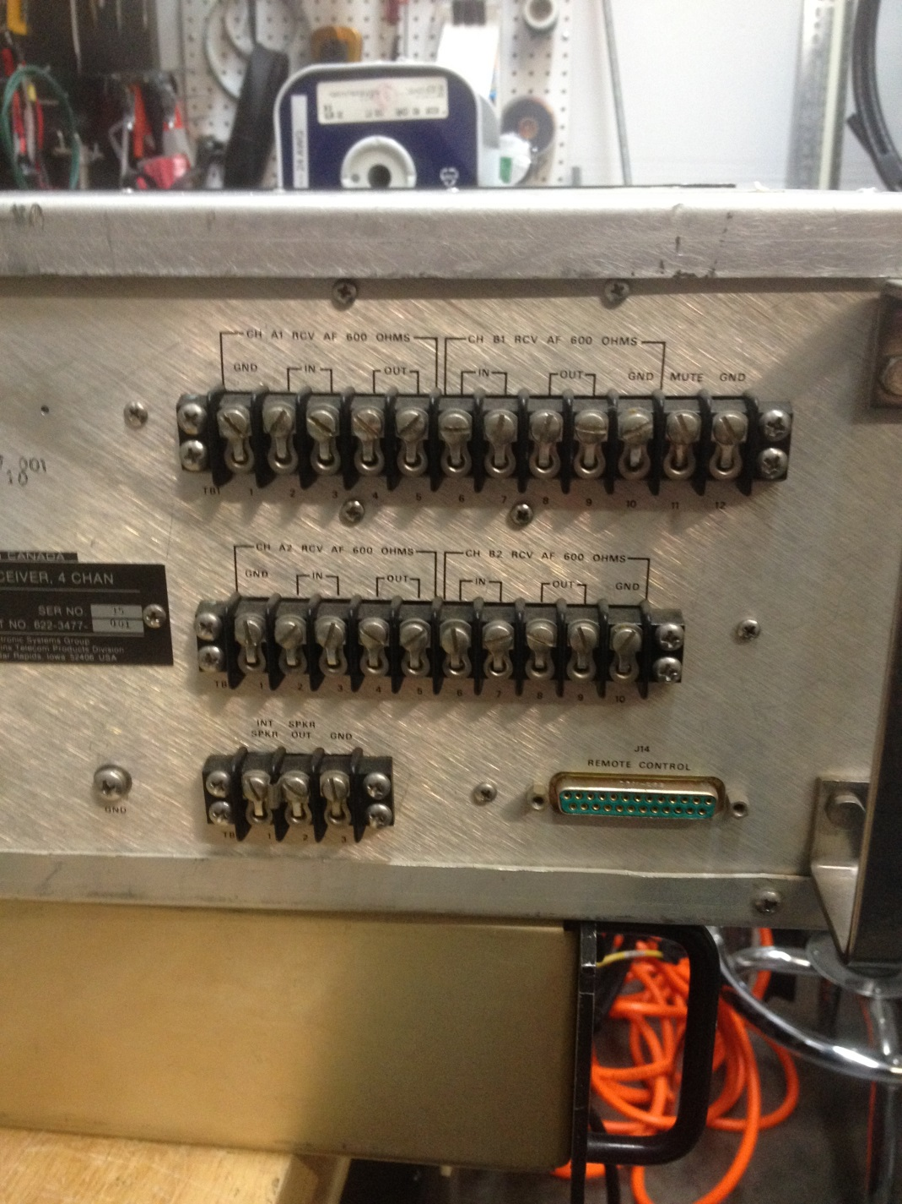
Rear Photo of the HF-8094 Receiver Control system

